Pre configuration:

Step 1: Firstly, share the c: drive.

Step 2: Enable file sharing options

Control panel🡪Network and sharing center🡪vEthernet (DockerNAT)🡪Properties and enable the following highlighted option if it is disabled.

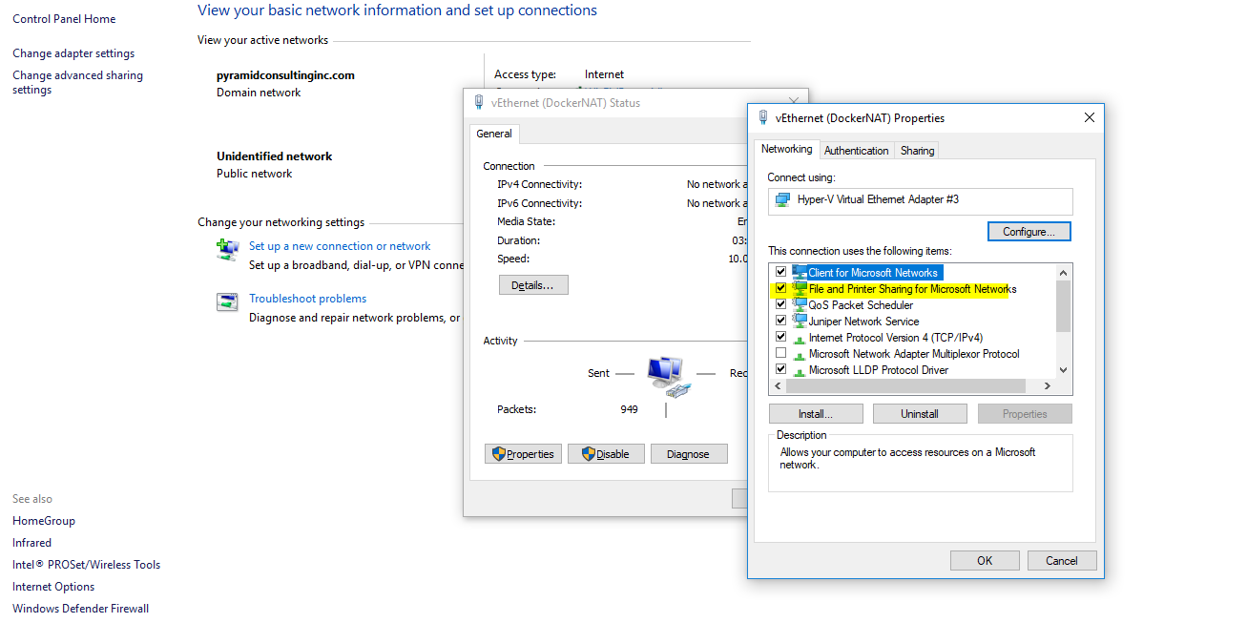

Step 3: Check firewall rules:

Control Panel\All Control Panel Items\Windows Defender Firewall and click on Advance settings

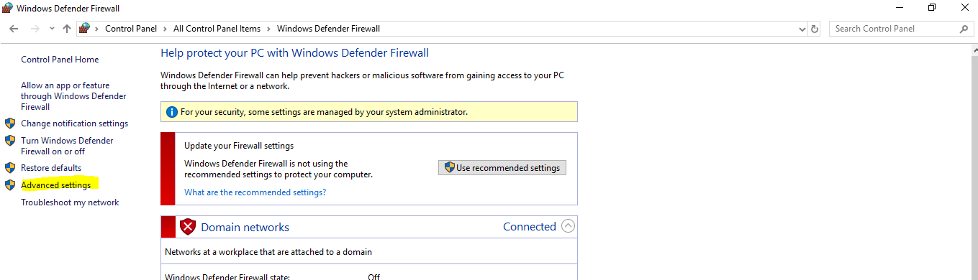

And now click on ‘Inbound Rules’ and enable the following highlighted settings

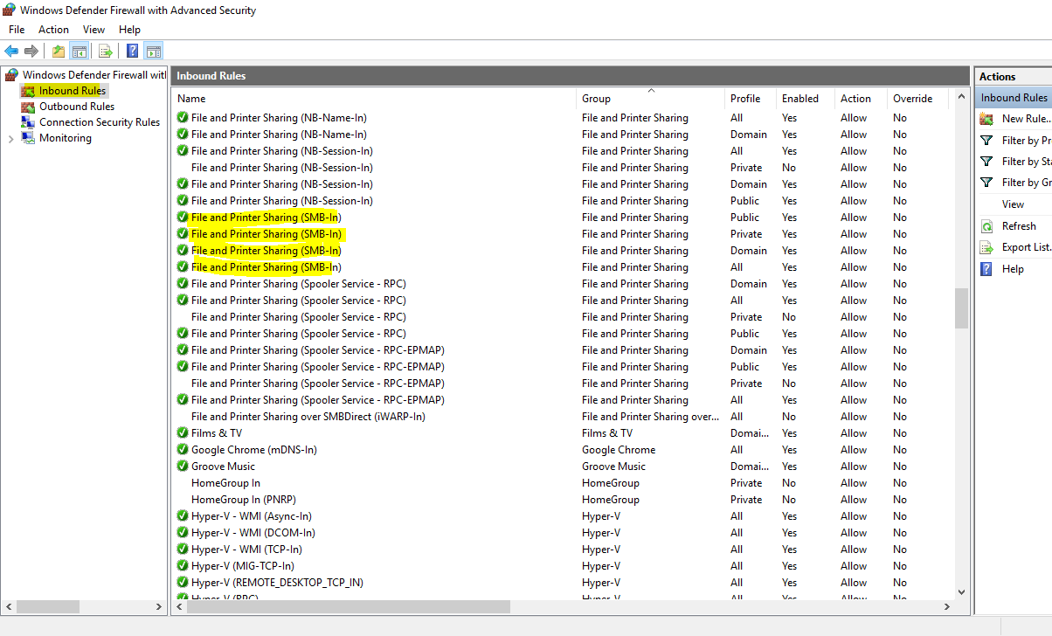

Step 4: Open Dockers settings

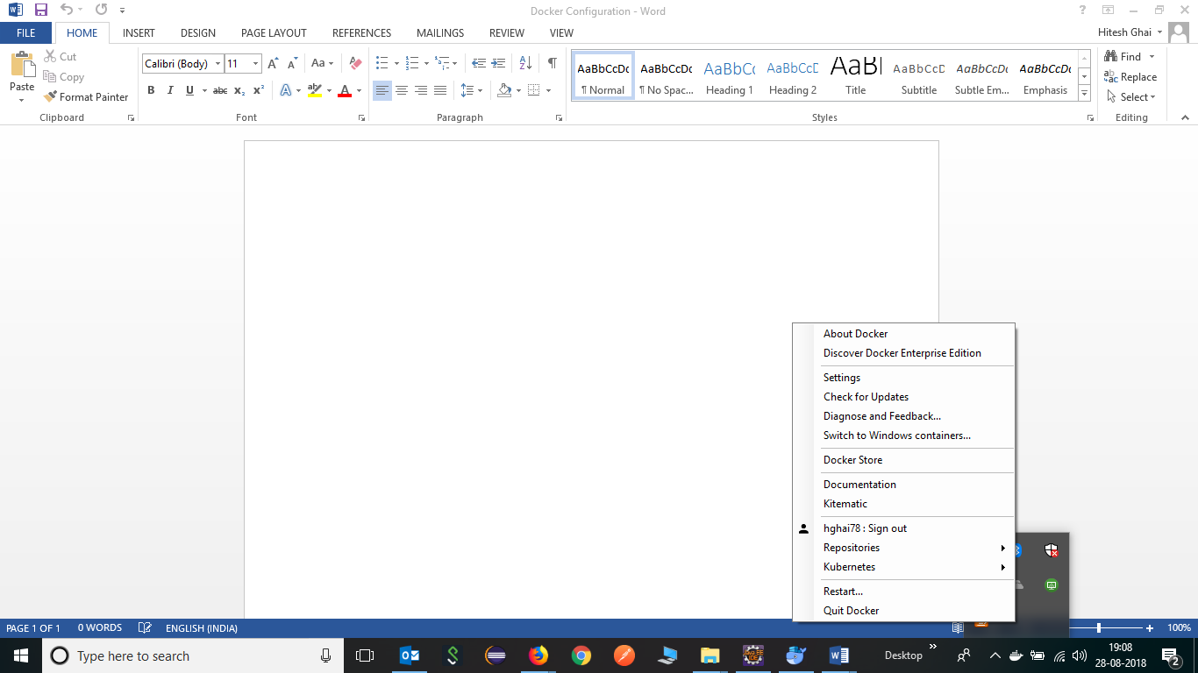

Step 5: Now map the C: drive

Note: VPN should be disconnected

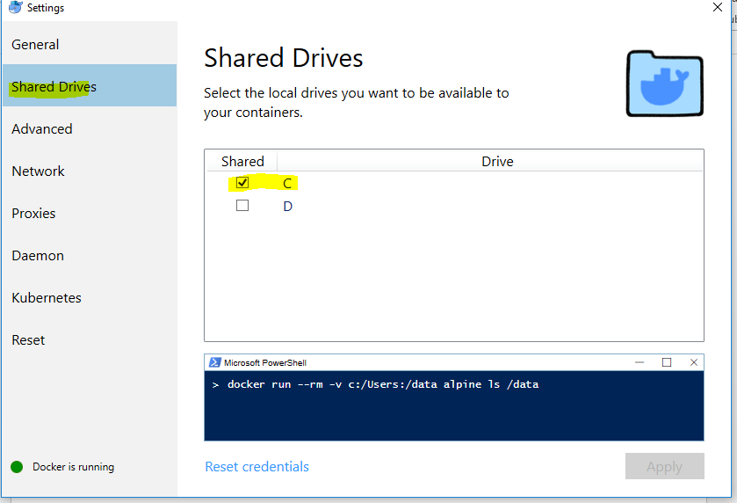

Step 6: Now open command prompt and issue the following command to check everything works fine

Note: In order to docker commands to work, docker should be up and running, otherwise the following error will occur.

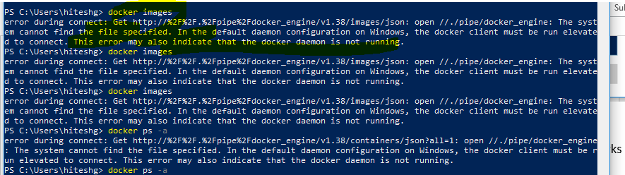

docker run --rm -v c:/Users:/data alpine ls /data

Step 7 : Pull chrome and firefox docker images.

Open <https://hub.docker.com> and search the following images

Step 8: Pull standalone-chrome-debug:3.6.0-bromine from the docker repository. We should only use this.

Note : node-chrome-debug : We should not use this image as chrome browser does not open in docker container.

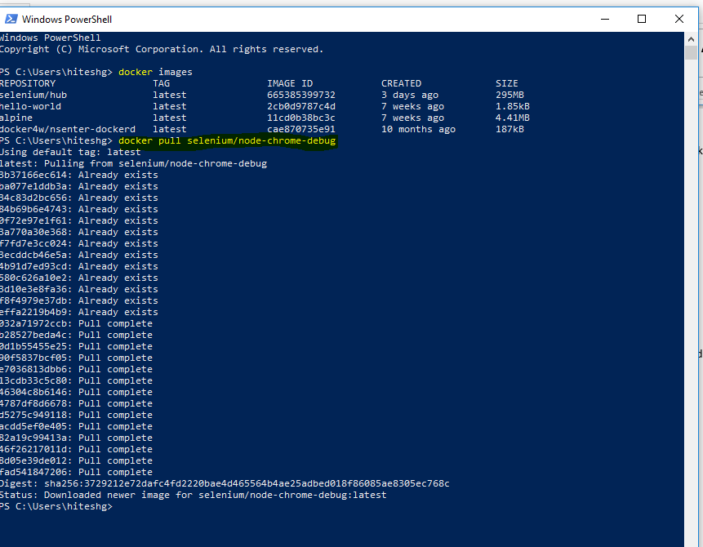

Firefox node image: docker pull selenium/node-firefox-debug

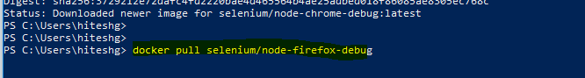

Another image: selenium node firefox



Another image: selenium node chrome



After downloading all the images

